Redshift DevOps

# Overview

CI/CD in the context of application development is a well-understood topic. Developers can use numerous patterns and tools to create pipelines to handle build, test, and deployment cycles when a new commit gets into version control. While there are solutions to manage application CI/CD pipeline, managing database versioning with rollback remains a challenge.

This blog post will demonstrate how DevOps best practices and CI/CD principles can be applied to DDL (Data Definition Language), DML (data manipulation language), and schema changes to a data warehouses like Amazon Redshift. We will also examine how test cases can be executed against changes deployed to an environment. In addition, database migrations and tests require connection information to the relevant Amazon Redshift cluster; we will demonstrate how this can be integrated securely using AWS Secrets Manager.

DDL and DML are considered code and should operate at the same level of rigor as application code. This means that the pipeline should be involved in running tests against deployed changes to minimize issues/challenges introduced in the production environment. Lastly, since we're automating DDL and DML scripts, this helps reduce inconsistencies between the environments.

# Proposed Architecture

We will use two deployment models for implementing this solution. In the first model, solution is deployed using Jenkins and Docker. Docker containers will be used to build a pipeline to a deploy DDL/DML changes. When a developer pushes SQL code into Git, webhooks trigger a build process in Jenkins. The job triggers a pipeline in Jenkins (both descriptive/scripted examples are provided) that builds a docker image (based on the docker config provided) and pushes the image into docker hub (The image is first updated in docker hub to ensure consistency). Jenkins pulls the docker hub image and deploys it as a container. Finally, Jenkins executes DDL/DML within the container.



# Running the Redshift pipeline

Jenkins builds a container with specifications provided in the docker file. Jenkins then executes a docker run command, this invokes the python program python_client_redshift_ephemeral.py, which reads two config (.ini) files.

The first file, dw_config.ini, contains configuration for Redshift cluster to be created . The second file, query_redshift_api.ini contains the SQL (DDL/DML/stored procedure) to be executed.

You can see how all of these works together by doing the following steps:

## 1. Clone the GitHub Repository

The AWS CloudFormation template and the source code for the example application can be found here: <https://github.com/aws-samples/devops-redshift.git> . Before you get started, you need to clone the repository using the following command:

git clone <https://github.com/aws-samples/devops-redshift.git>

This will create a new folder, redshift_devops, with the files inside.

## 2. Deploy CloudFormation Template

Go to the CloudFormation console and click "Create Stack," then choose "With new resources (standard)."

Once you're on the "Create stack" page, choose "Upload a template file" and then "Choose file." The file should be in <cloned_directory>/cloudformation_Redshift_devops.yml. After you select the file, your screen should look like the following:

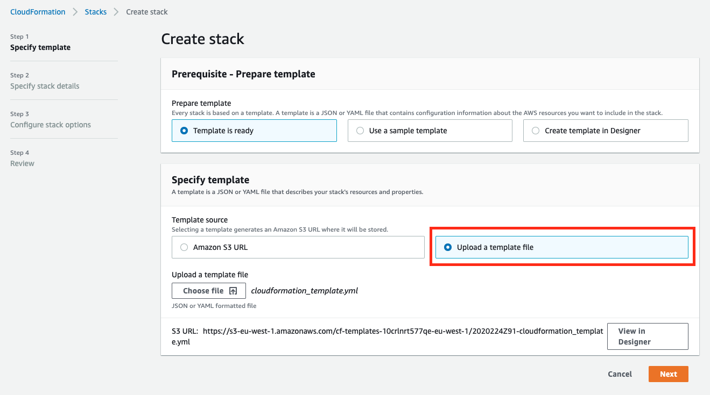

Click "Next" and complete the following parameters:

* Stack name – we will use RedshiftDevOps
* DataBucketName – S3 bucket name
* Key – Your pem key to connect to ec2 instance.
* Master user name
* Master password for both test and prod Amazon Redshift clusters. The password has the following criteria:
  + Must be 8-64 characters.
  + Must contain at least one uppercase letter.
  + Must contain at least one lowercase letter.
  + Must contain at least one number.
  + Can only contain ASCII characters (ASCII codes 33-126), except' (single quotation mark)," (double quotation mark), /, \, or @.
* Redshift node count (default:dsc2 – 1 node)
* Your public IP

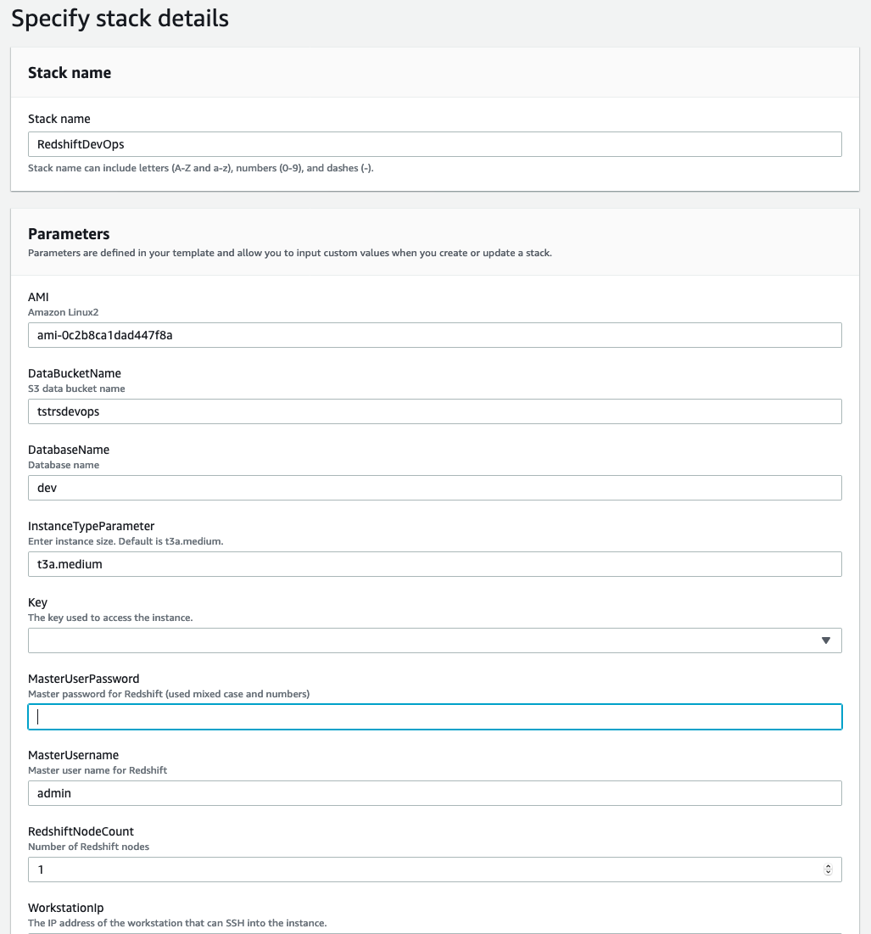

Click "Next"

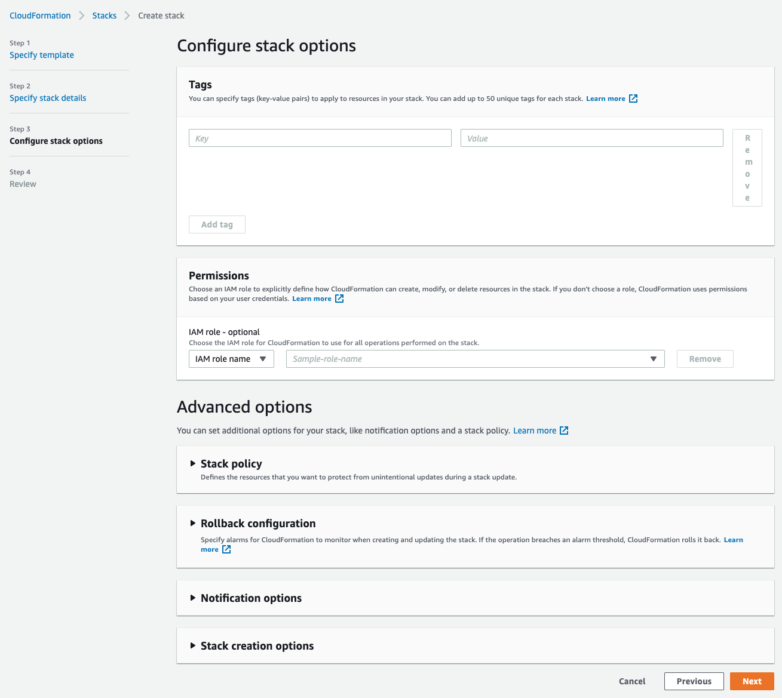

We can leave everything as is on this page and click "Next."

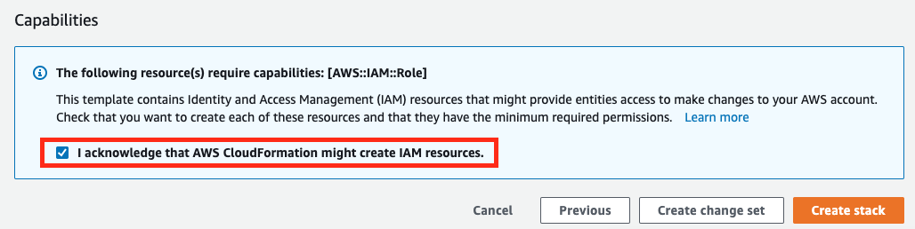

Lastly, scroll to the bottom of the page, check the acknowledgment, and click "Create stack." The stack will create the VPC, Amazon Redshift clusters, ec2 instance deploy a container on ec2 running Jenkins.

Click the refresh button on the top right corner to track the progress of the stack creation.

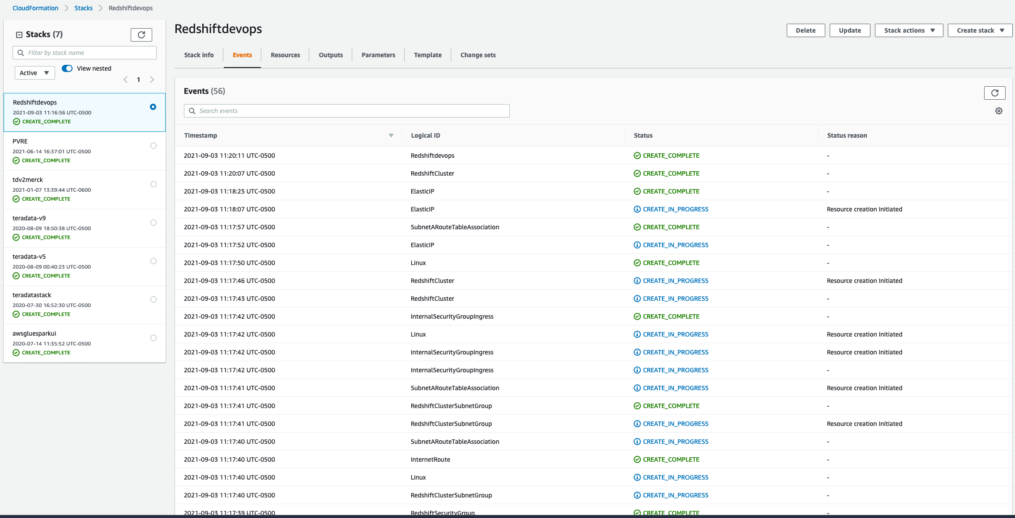

3. Connect to ec2 instance and verify docker container is running.

Use SSH to log on to the ec2 instance using the .pem file selected in cloud formation.

Once logged on to ec2 instance, run the command:

docker ps -a

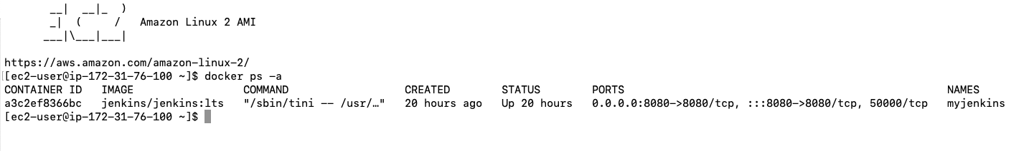

myjenkins docker container is deployed mapping ec2 host folders with myjenkins container. This will preserve the state of the Jenkins application (metadata, jobs, etc.) even though the container exits. If the container were to be re-started, configurations would not be lost.

If the container exits for any reason, execute the following command on the terminal:

*docker run -d -p 8080:8080 --name myjenkins -v /var/run/docker.sock:/var/run/docker.sock -v jenkins_home:/var/jenkins_home -v jenkins_downloads:/var/jenkins_home/downloads jenkins/jenkins:lts*

4. Once done, log on to Jenkins ec2url+jenkinsport

Copy the URL and paste it into a web browser (chrome, firefox recommended). Please note that the URL will be unique to you and a public ec2 instance name deployed by CFN. Port 8080 is used for web traffic.

http://ec2-34-239-162-89.compute-1.amazonaws.com:8080/

A screen asking for the administrator password will be displayed.

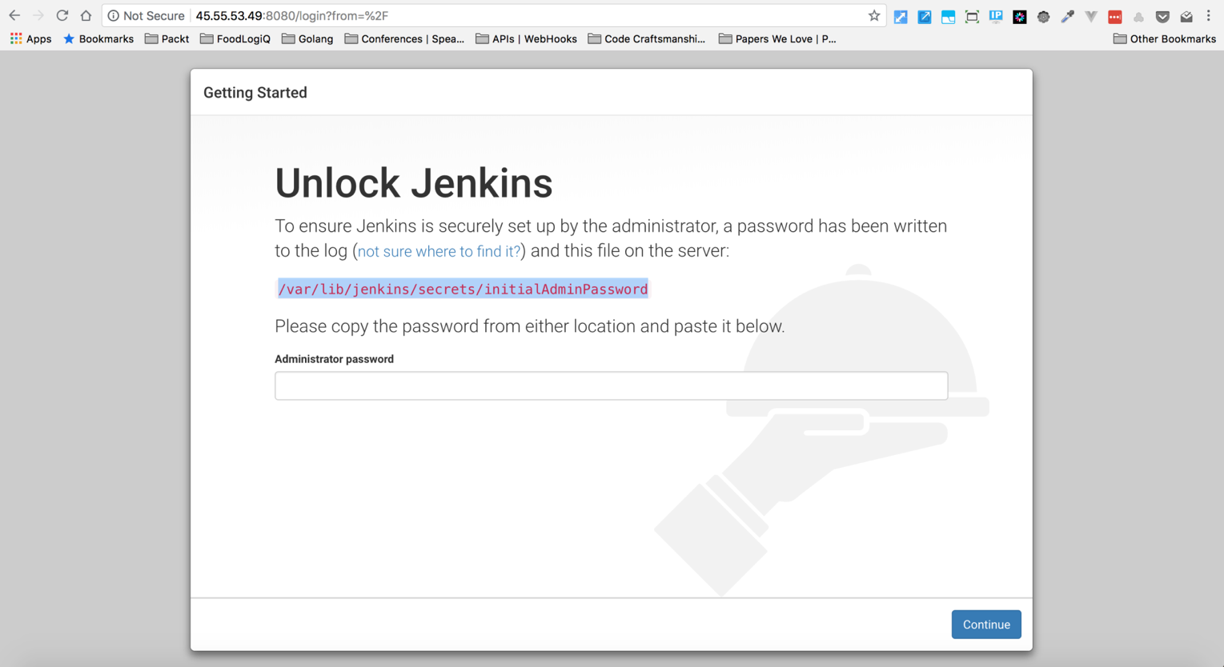

Log on to the Jenkins container from terminal using the command

*docker exec -it myjenkins /bin/bash*

Once inside the container shell, execute the command:

*cat /var/lib/jenkins/secrets/initialAdminPassword*

5. The simplest and most common way of installing plugins is through the **Manage Jenkins** > **Manage Plugins**. Click **Available** to view all the Jenkins plugins that can be installed. Using the search box, search for **Docker Plugin**. Select **Docker, Docker API Plugin, Docker Pipeline,docker-build-step**

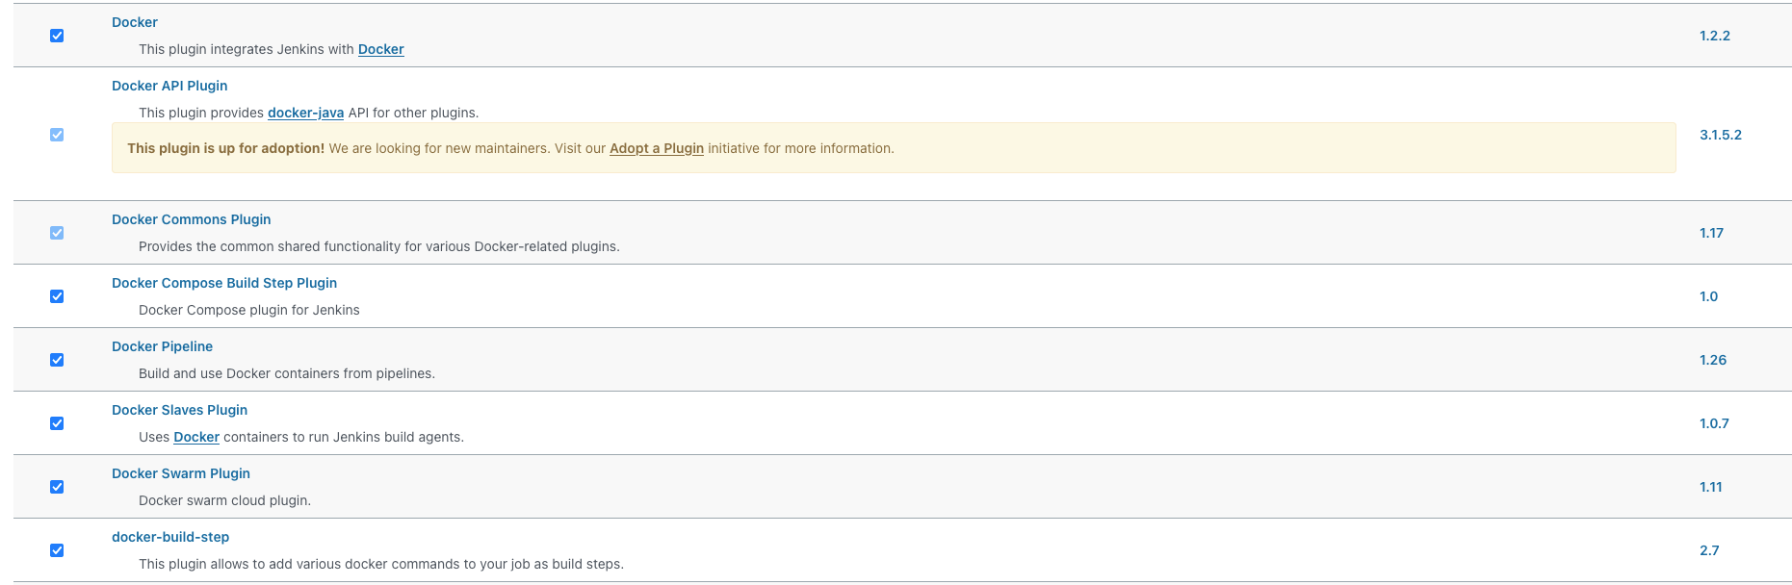

6. We are adding security credentials within Jenkins.

Next, we will add credentials for accessing Docker, GitHub, and AWS accounts. Click

Dashboard> Manage Jenkins> Manage Credentials > Jenkins (stores secrets)

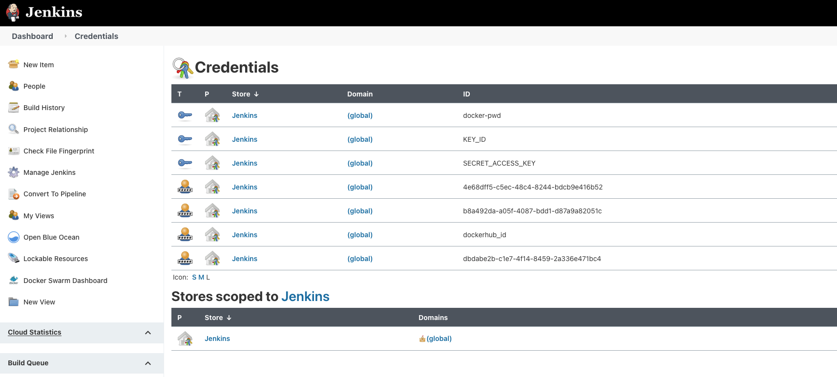

Click Add credential, create an id (you can create a custom id, or you could use the

default guide provided by Jenkins).

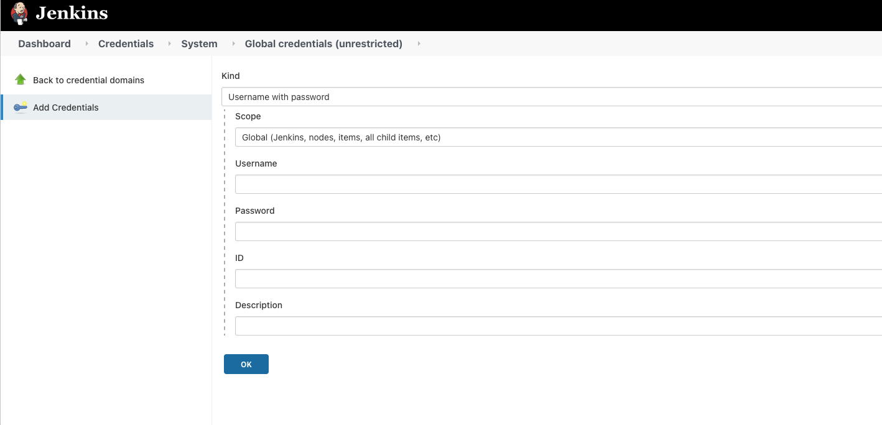

On the "Kind" drop-down box, select GithubApp define username and password click

ok. Repeat the same process for Docker. Select kind as secret text and then add AWS secret.

7. Jenkins 2.0 allows pipeline creation as code, as an essential part of continuous delivery (CD). The declarative pipeline is groovy-based; having a programming language to build pipelines avoids runtime issues with the build script.

On the left pane, select New Item>Pipeline> "Redshift_declarative_pipeline" as the name of the declarative pipeline.

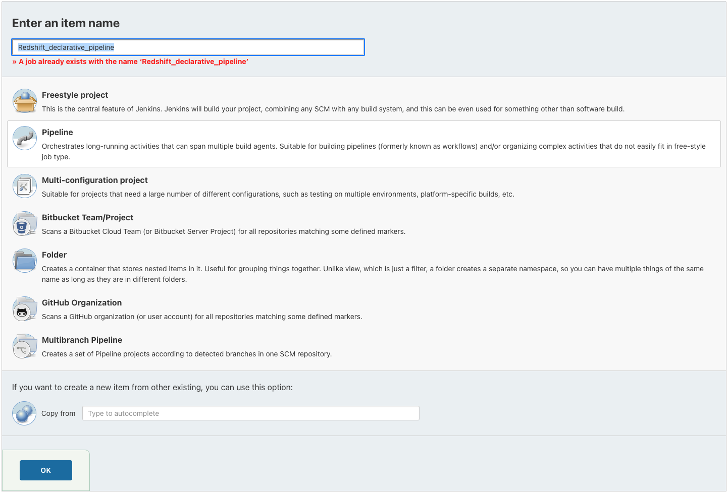

Describe the pipeline. Select a build trigger; we would like to create a based on changes made to the git repo. Click the check box "GitHub hook trigger for GITScm polling."

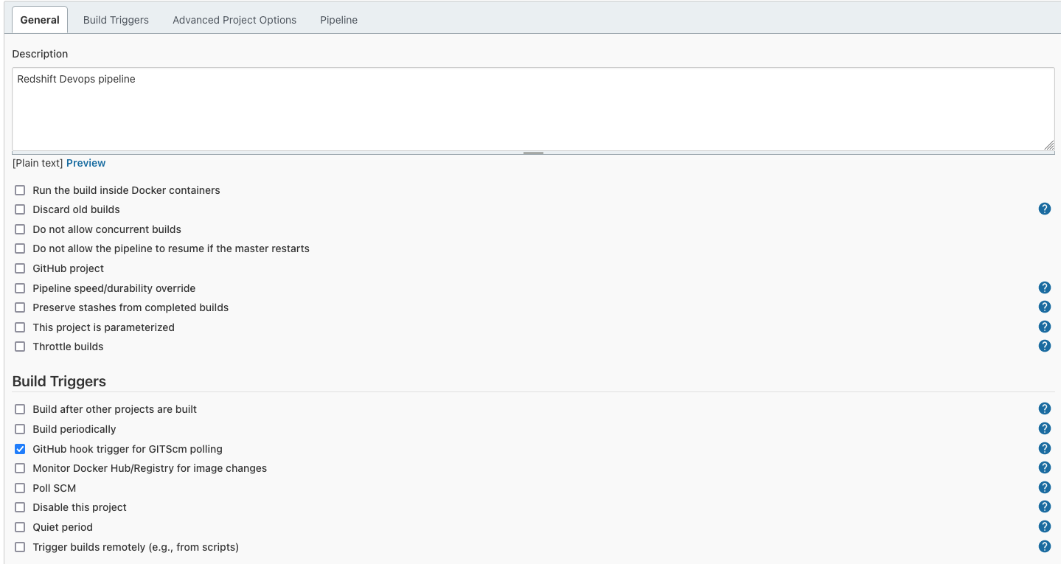

In the Advanced Project Options. For pipeline definition drop-down, select "Pipeline script from SCM." Script path will look for the file to be used for declarative pipeline, type in the name as Jenkinsfile. Select Git as SCM and provide the repository URL for the Github repo. For credentials, select Github credentials added. Click Save.

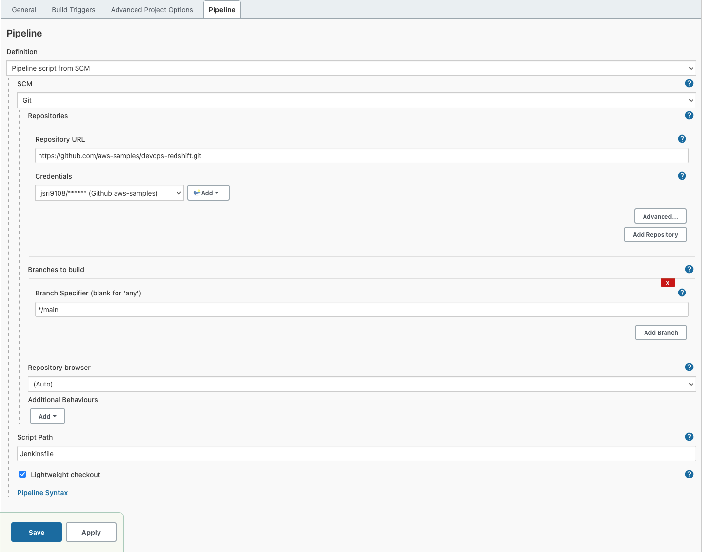

8. You can decide to run either a Declarative or scripted pipeline. Declarative pipelines are preferred as they allow the pipeline to be managed as code. In this step we show, how to implement a scripted pipeline.

To begin, navigate to Jenkins homepage, and on the left pane, select New Item>Pipeline> "redshift_devops_scripted_pipeline" as the name of the scripted pipeline.

Select "pipeline script" as a definition in the advance project option. Copy contents from Jenkins_scripted_pipeline.txt into the script section. In the script, replace variable name – DOCKERRPONAME with the docker repo created and YOURDOCKERLOGON with your Docker in the login name.

Also, note that AWS_DEFAULT_REGION is set as 'us-west-2'. You can modify the region based on your preference.

After changes have been made, click save and apply.

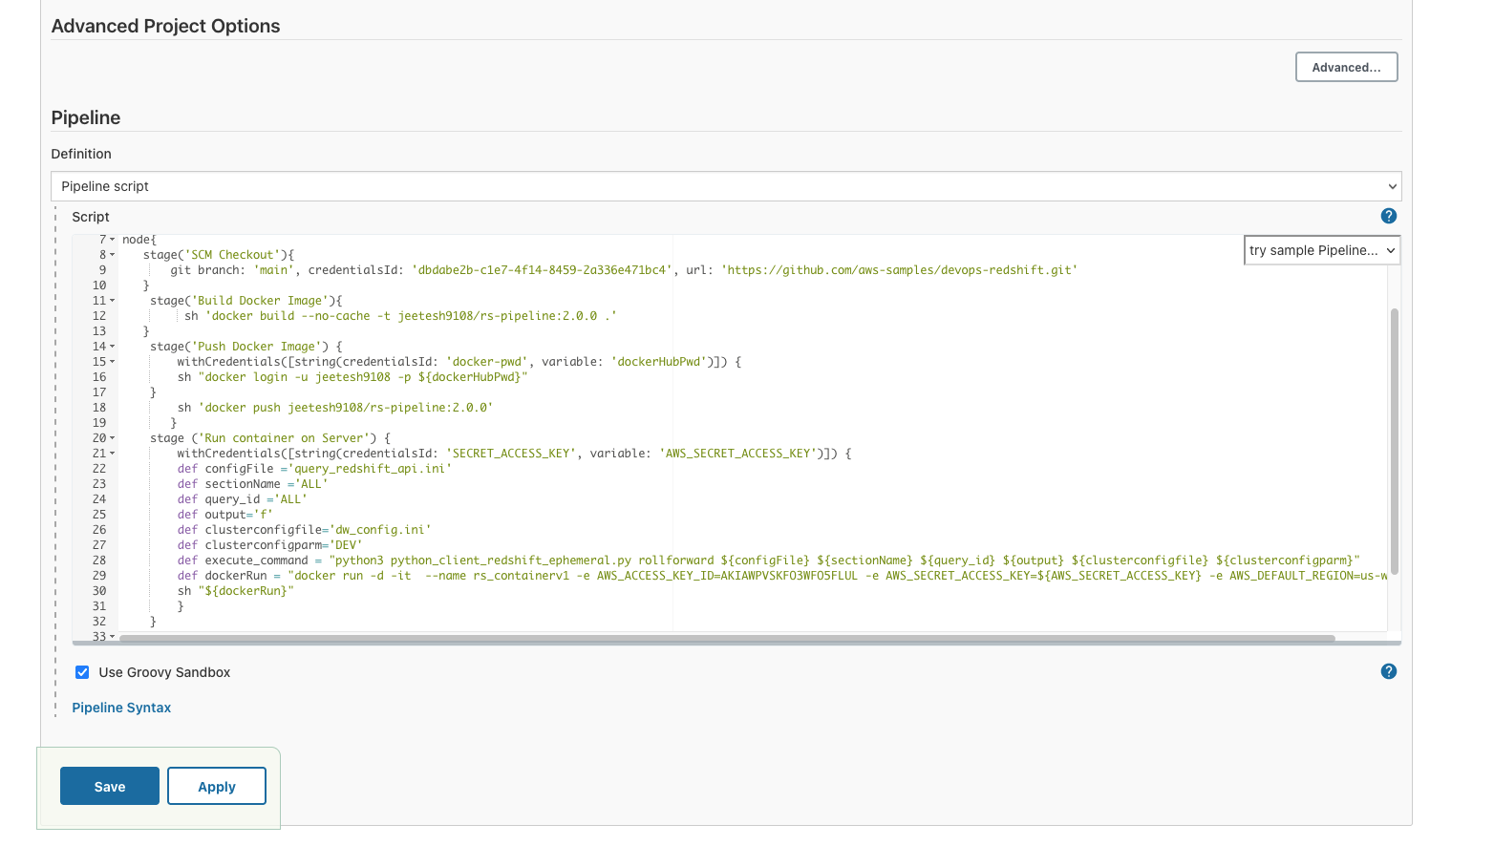

9. Navigate to your git account containing cloned DevOps-redshift repository and click settings. Click webhooks on the left-hand side pane; it should open the manage webhook window. Put the Jenkins URL with the/GitHub-webhook/ URI path in the payload URL.

<http://ec2-34-239-162-89.compute-1.amazonaws.com:8080/github-webhook/>

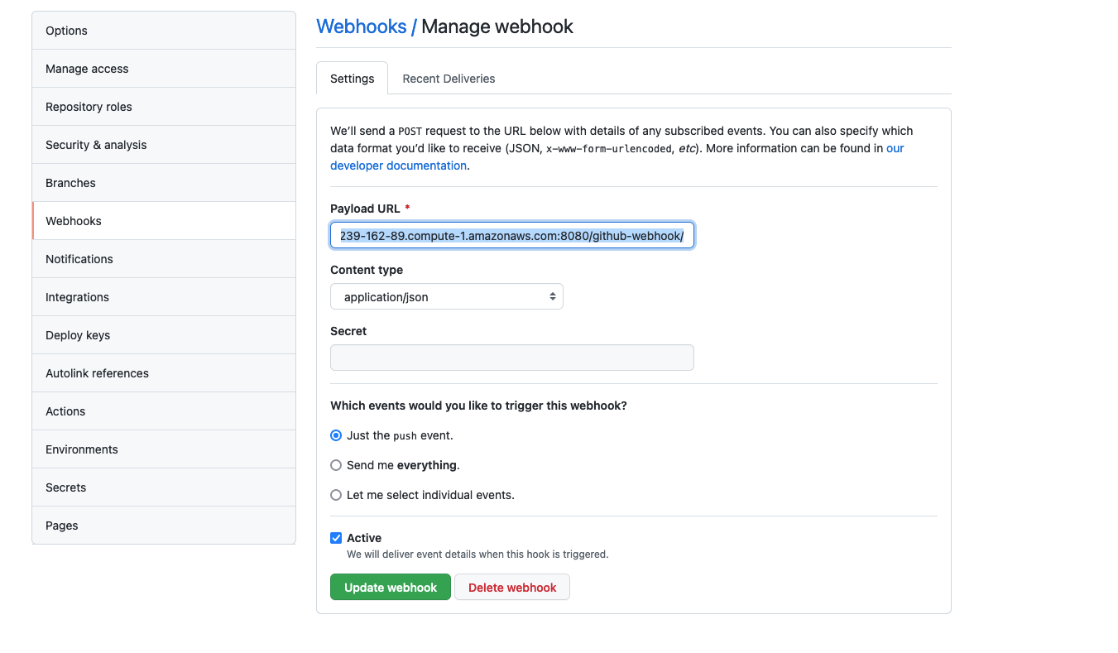

This webhook notifies Jenkins to trigger a build when changes are committed to the GitHub repository.

10. Copy and paste the below lines in the query_redshift_api.ini file

[DDL_v08]  
query6 = create table test_table_service (col1 varchar(10), col2 varchar(20));

And commit the changes.

11. Git will send an event to the Jenkins server to start the build. If all works, you should

see the Jenkins job automatically triggered at this point.

12. Once the Jenkins job has been completed, you should have the container running.

Navigate to the terminal and run docker ps -a to check the container. You should see

a container rs_containerv1 running.

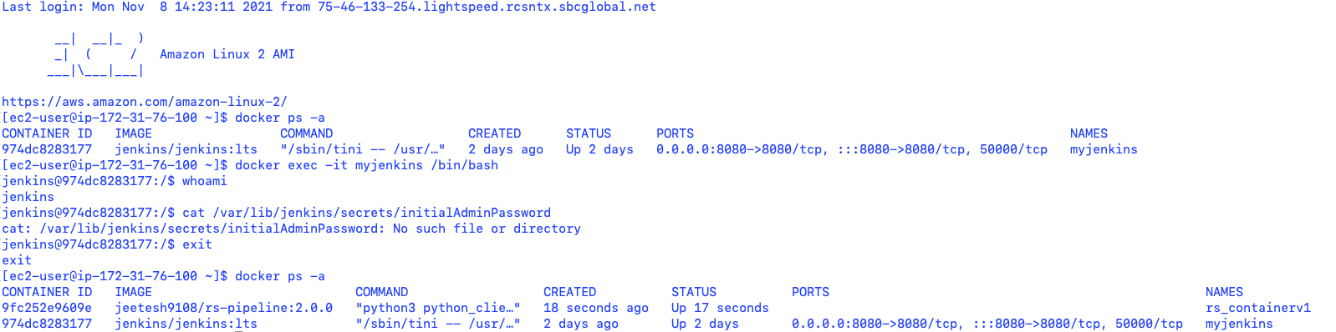

13. To verify the steps executed by the docker container, check the logs. Run,

*docker logs rs_containerv1 -f*

to see the log lines getting generated.

14. The process will execute test cases, and print assertions result for values specified in

the results section.

15. Finally, log on to console 🡪 Redshift 🡪 clusters and you will a new cluster based on

the cluster name provided in the clusterconfig.ini file.

16. Once all the execution steps are completed, container will show a status of

EXITED(0). You do not need to remove the stopped container, Jenkins pipeline

automatically does that when starting.

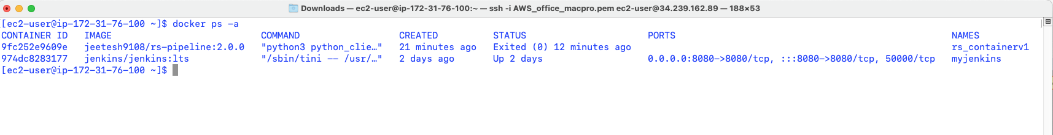

## Redshift CI/CD using AWS services

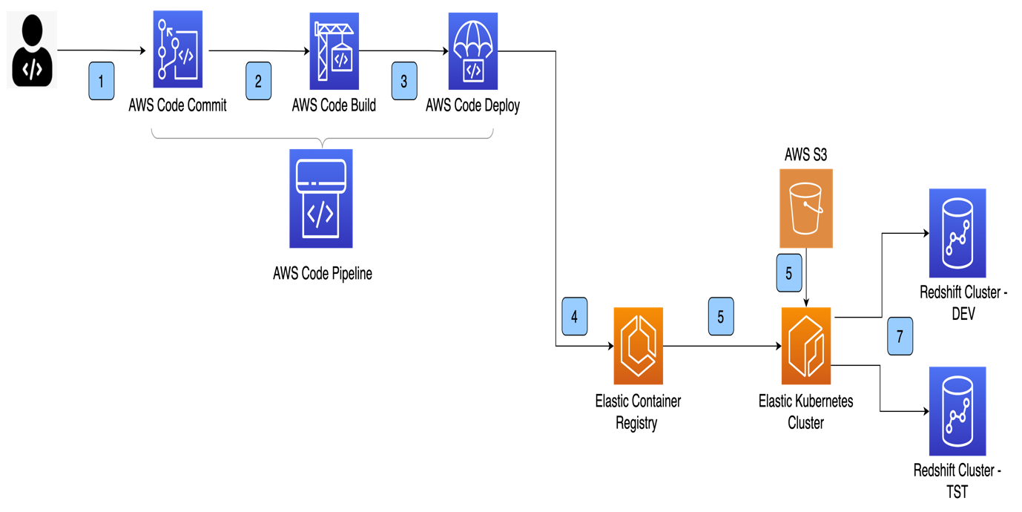

Event Flow

1. A developer adds/modifies DDL/DML scripts in configuration files and commits changes into AWS code commit .
2. AWS code commit triggers off a code build using configuration specified in buildspec.yml. The build happens based on pre_build, build and post_build command.
3. AWS code builds the container image and pushes it to AWS code deploy.
4. Code deploy pushes the container image to Elastic container Registry (ECR) repository.
5. EKS cluster picks up the container image , reads configuration in s3 bucket to determine execution step, connects with Redshift cluster and executes DDL/DML code.
6. Code gets deployed in Redshift cluster environment, task completes and the deployment service waits for another change to DDL/DML script.

This section will implement the same CI/CD pipeline we reviewed but will use AWS CI/CD services components. Below are the component details:

|  |  |
| --- | --- |
| [AWS CodeCommit](https://aws.amazon.com/codecommit/) | This is the version control system where you will be storing your code. |
| [AWS CodeBuild](https://aws.amazon.com/codebuild/) | This service will build and start the containers to create environment and runtime components for code execution. The file "buildspec.yml "is used to build the container image   * **Prebuild:** Logs on to private repository on AWS ECR (Elastic Container Repository), builds an image based on the docker file specified. * **Build:** A base image of ubuntu 18.04 is pulled from the docker hub, Linux packages, python 3.7, AWS CLI are installed, and code from the repo is copied to the src directory of the container. * **Post-build:** Docker image is pushed to the ECR repository and tagged as the latest image. |
| AWS ECS | A cluster is created using the AWS ECS service. A task to deploy DDL runs as a service to deploy the DDL/DML and execute test cases. The task picks up the latest image created by CodeBuild to deploy the changes. |
| [AWS CodePipeline](https://aws.amazon.com/codepipeline/) | Responsible for the overall orchestration from source to Redshift cluster deployment |

As you can tell from the description of the different components above, we're also using some additional dependencies at the code level; these are as follows:

|  |  |
| --- | --- |
| Pyunit | The open-source testing framework used to execute test cases against the changes that have been deployed on the Redshift cluster. |

In the succeeding sections, we will be diving deeper into how all of these integrate.

## Push Code to the CodeCommit Repository

We will create a new repository, redshift_devops. Navigate to AWS console> codebuild>create a repository and provide the name and description on the create repository form.

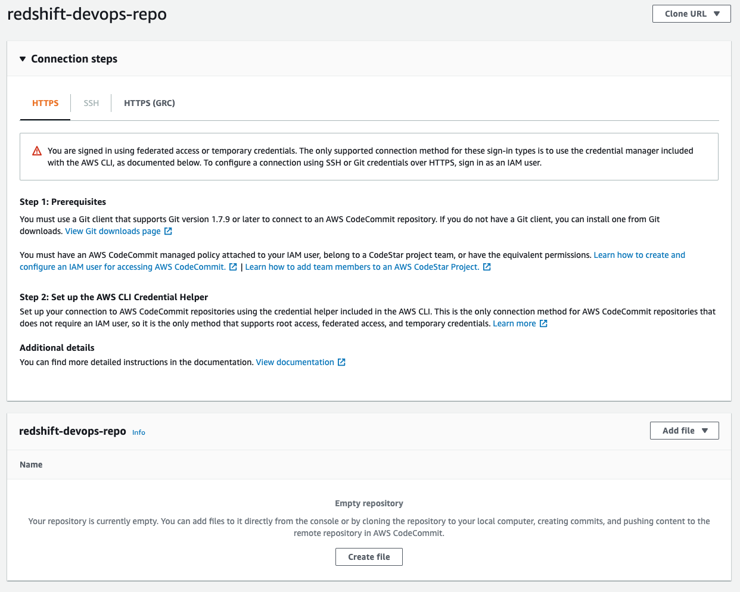

Before you can push any code into this repo, you have to set up your Git credentials follow the steps outlined in the [CodeCommit documentation](https://docs.aws.amazon.com/codecommit/latest/userguide/setting-up-gc.html) on how to do this. Once you reach Step 4, copy the HTTPS URL, and instead of cloning, we would be adding the CodeCommit repo URL into the code that we cloned earlier by doing the following steps:

git remote add code commit <repo_https_url>

git push code commit main

The last step will populate the repository, and you can confirm it by refreshing the CodeCommit console. If you get prompted for username and password, input the Git credentials you generated and downloaded from Step 3.

## AWS CodeBuild

Navigate to AWS console> CodeBuild and select create build project.

1. Project name as redshiftdevops.
2. Description of the build project. Providing the following details:

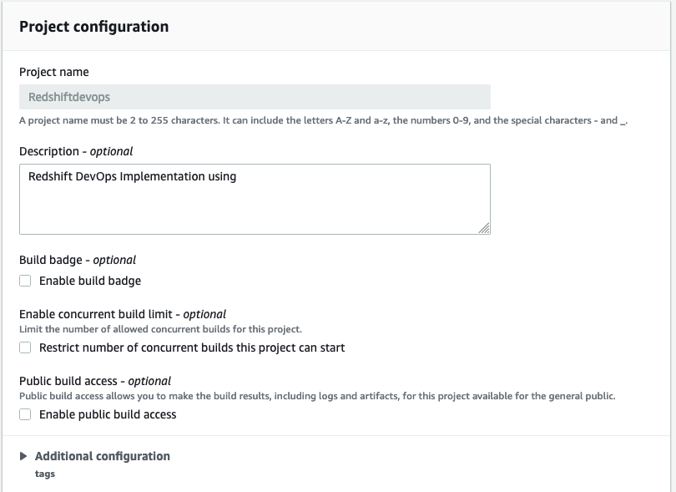

1. Source – on the drop-down, select AWS CodeCommit

The repository's name should be auto-populated; select the CodeBuild repository created in the previous step. Select the branch as master

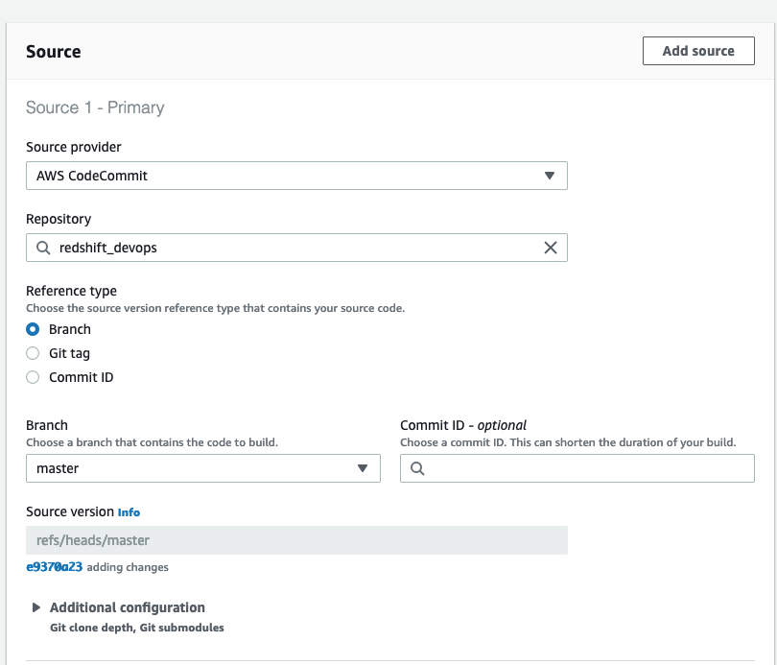

1. Environment Image – select managed image

The operating system as Ubuntu or Amazon Linux 2

Runtime – standard

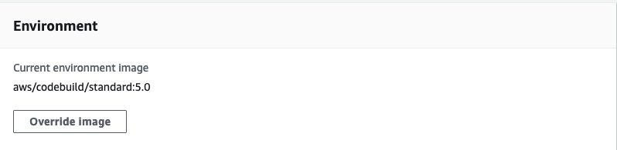

1. Service role – You can either create a new service role or select an existing service role you might have created. For IAM policy details, please refer to the [link](https://docs.aws.amazon.com/codebuild/latest/userguide/setting-up.html)
2. BuildSpec file – AWS CodeBuild uses the buildspec.yml file to perform the prebuild, buil,d and post-build steps. This file must be defined in the root directory of the CodeCommit repo. You can also define a custom name and location of the buildspec.yml file and provide the details.

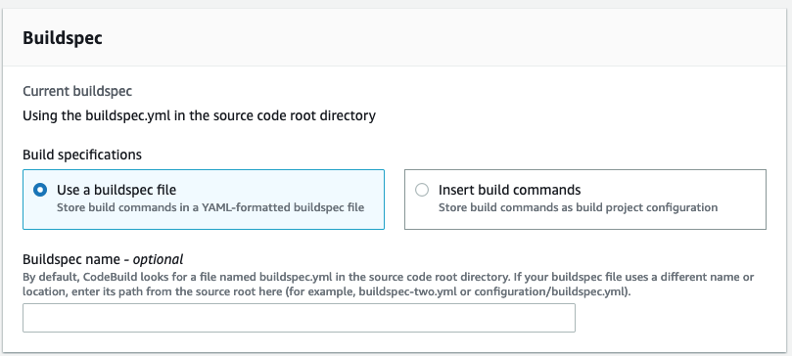

1. Artifacts – we will not generate any artifacts but upload the container image directly to ECR. Select the Type as No artifacts.

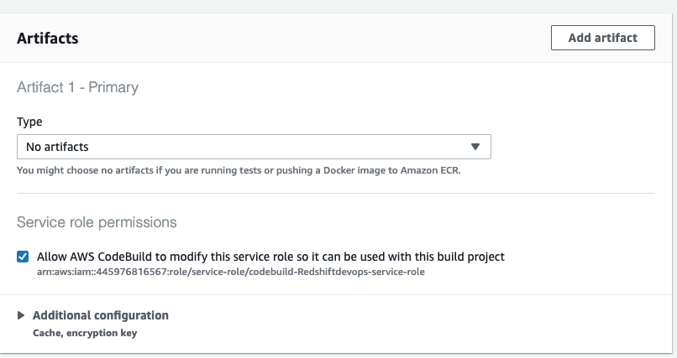

1. Logs – Add a group name and stream name to capture the logs.

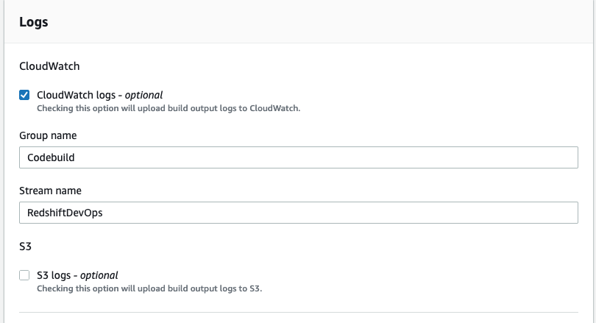

Once all the details have been provided, click the "create build project button."

## AWS Elastic Container Registry(ECR)

In the next step, we will create a private ECR repo to host the build image created by the AWS Build service. Navigate to ECRAWS console > ECR.

Click create a repository, select the privacy setting as private and provide a repository name.

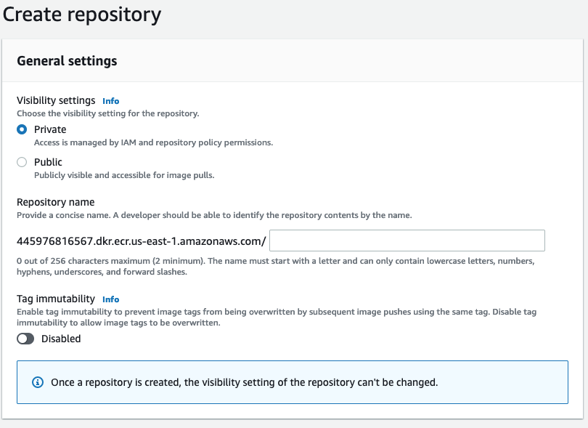

Please note that visibility settings cannot be changed once an ECR repository has been created.

## AWS Elastic Container Service (ECS)

From the AWS console, navigate to ECS (Elastic container service). Click create cluster and select the option as "Networking only," as we will be using AWS Fargate to create and manage our cluster service. Click next, provide cluster name and click create.

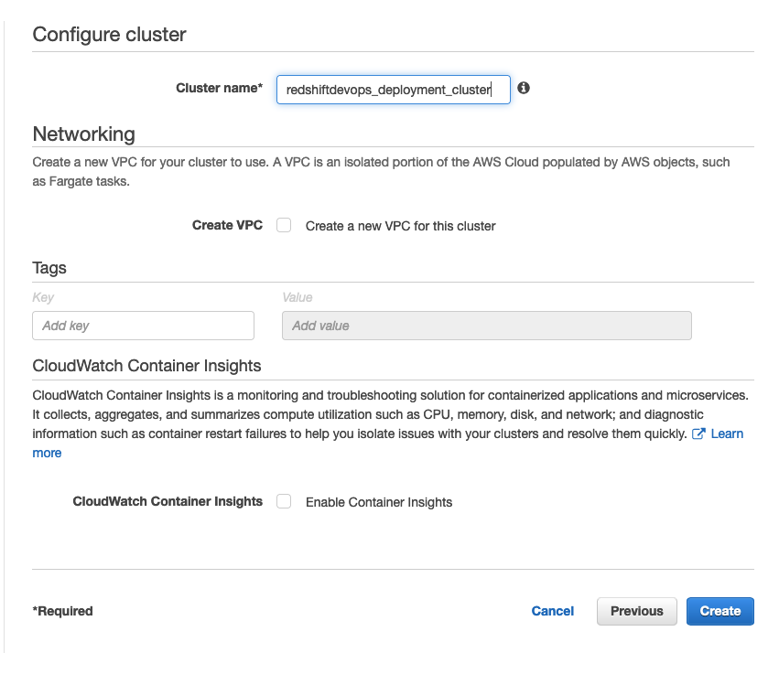

Select Task Definitions click to create a new task definition on the left-hand pane. On Launch type compatibility, select FARGATE and click next. This will present the task and container definition screen. Provide the following details:

1. Task definition name – Task name
2. Task role – The dropdown should provide ecsTaskExecutionRole
3. Operating system family - Linux
4. Task execution role – ecsTaskExecutionRole
5. Task memory – 2 GB
6. Task vCPU – 1 vCPU

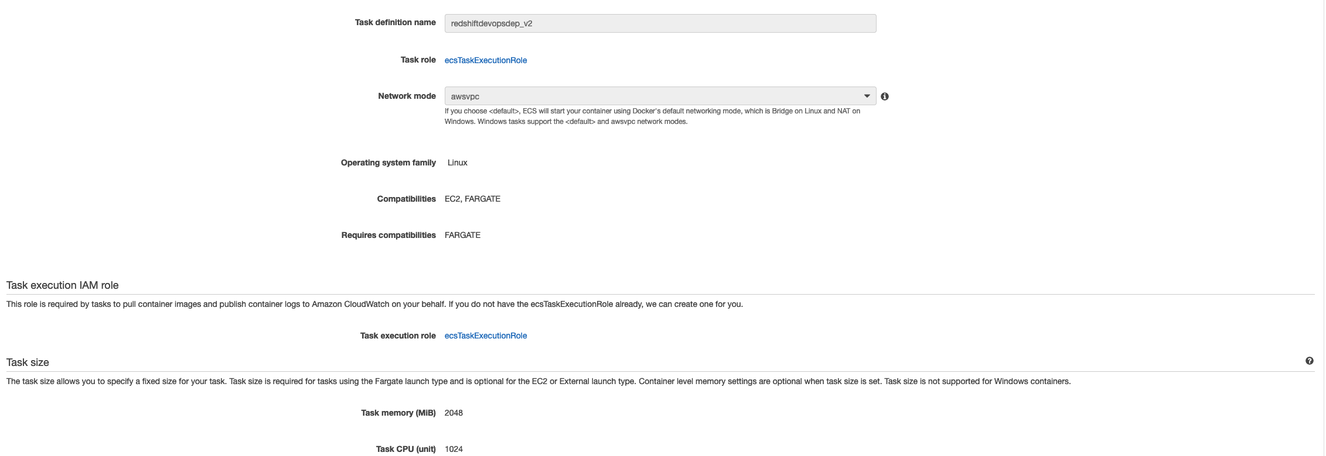

1. Click Add Container, and it would present a new screen:
   1. Container name – Name of the container running the deployment pipeline
   2. Image – URI of the private ECS repo created

*AWSACCOUNTNUMBER.dkr.ecr.us-east-1.amazonaws.com/redshiftdevops:redshiftdevops*

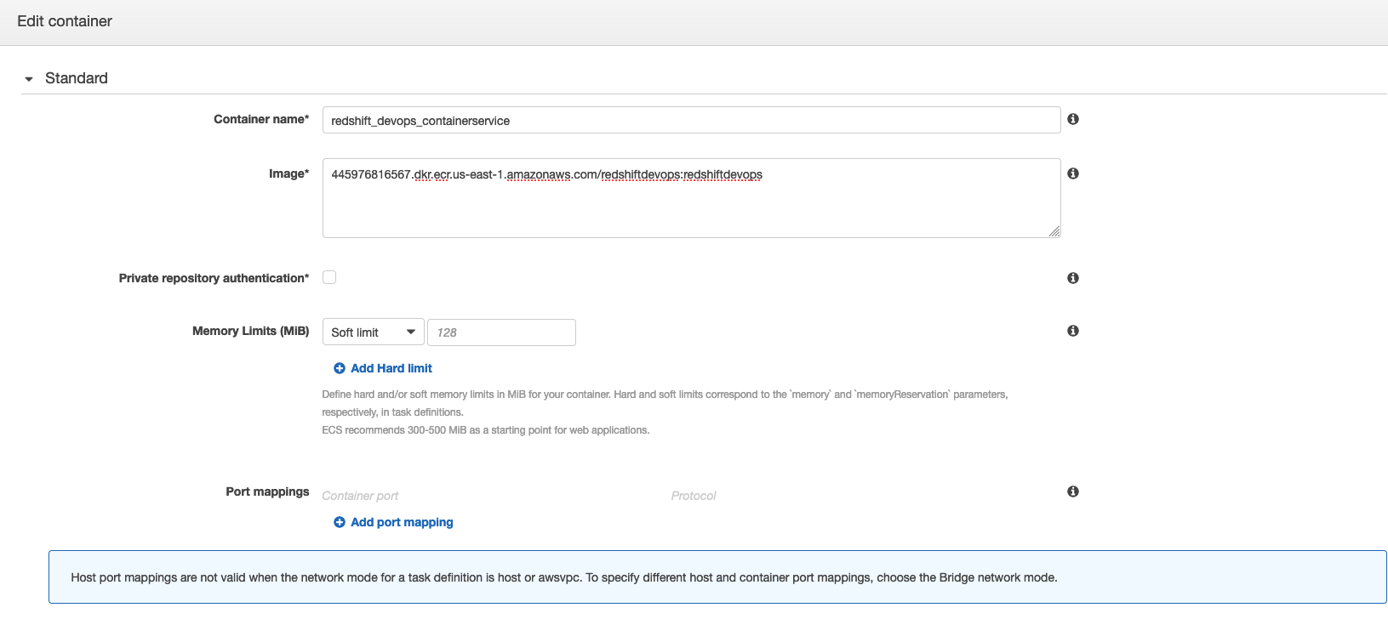

* 1. CPU Units - 1
  2. Environment – Paste the following command:

*python3,python_client_redshift_ephemeral.py,rollforward,query_redshift_api.ini,ALL,ALL,s,dw_config.ini, DEV*

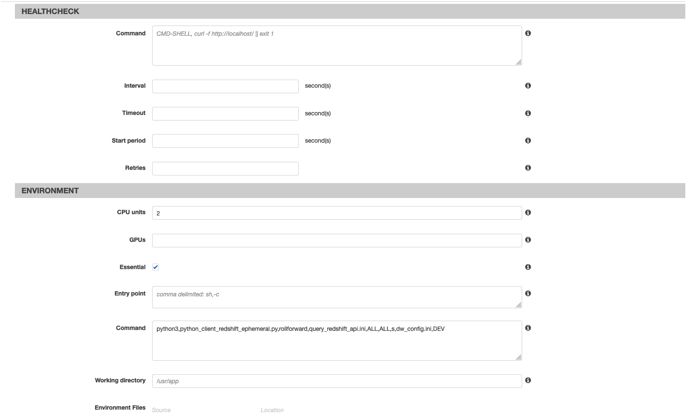

Leave the other parameter as blank and click create. This step completes the ECS cluster and task definition needed to deploy changes to the Redshift database.

1. Select Task definitions on the left-hand pane, check box task created, click actions, and select deploy as a service.

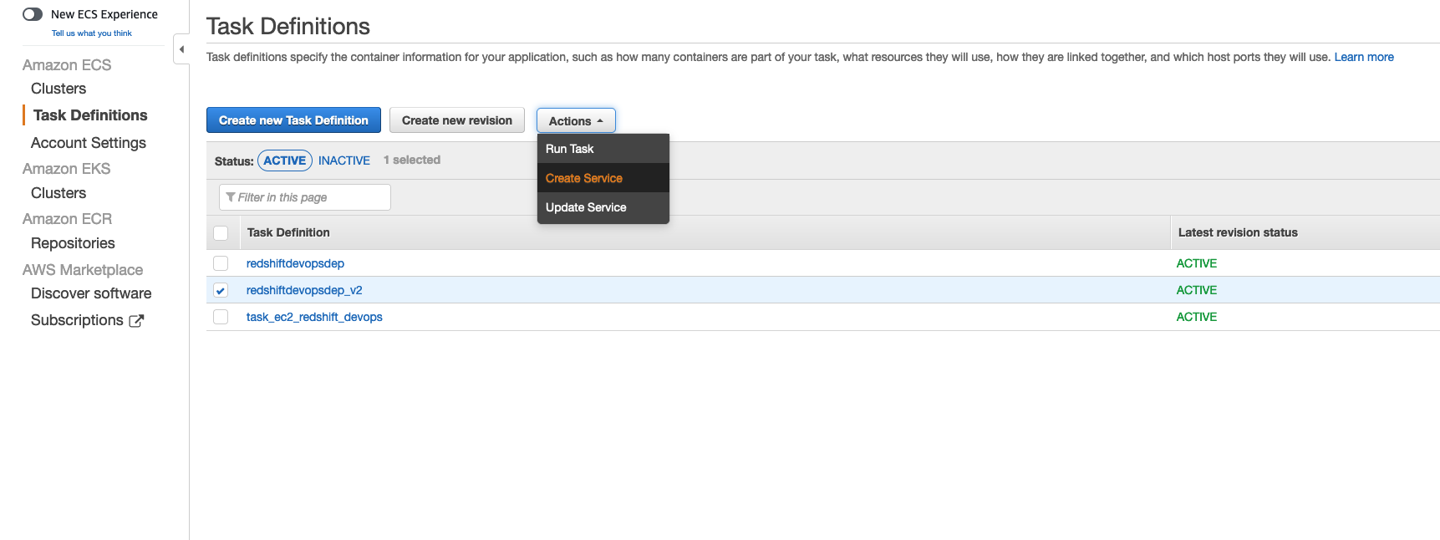

This step created the task as a continuous service, which picks up changes and deploys them to the Redshift cluster.

## AWS CodePipeline

To bring all of these components together, we will be using CodePipeline to orchestrate the flow from source code until code deployment. There are some additional capabilities you can do with CodePipeline. For example, you can add an [Approval step](https://docs.aws.amazon.com/codepipeline/latest/userguide/approvals-action-add.html) after a code change is made for someone to review and perform a build and deploy.

Navigate to CodePipeline from the console and click create the pipeline. Our pipeline will consist of the Add source stage and Add build stage. Provide a pipeline name and choose an existing or new IAM service to deploy the change. Click Next

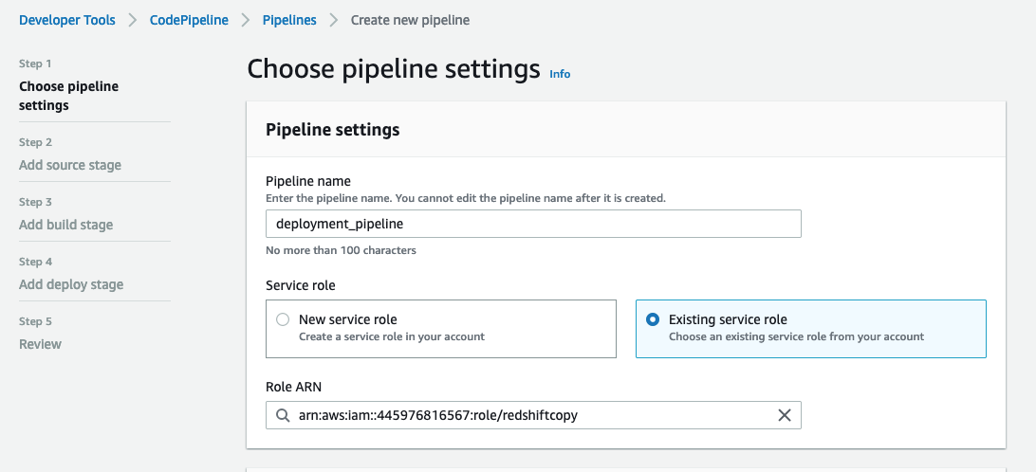

Click Next and select source provider ad AWS CodeCommit. Select repository name from the drop-down and Branch name as master.

# 

Add the build stage by selecting code provider as AWS CodeBuild, Region, and Project name. Select Build type as Single Build. Click Next and click skip deploy stage.

Review the changes and click create a pipeline; this should create the pipeline needed.

# Example Scenario

Let's take an example scenario; we would add two new queries in the redshift_query.ini file to execute on the existing Redshift cluster. Copy the below lines towards the end of the file.

**[DDL_v08]  
query6** = **create table test_table_service(col1 varchar(10), col2 varchar(20));**

We will need to commit the changes by running the following commands on terminal.

git add .

git commit -m "changes to query.ini file."

git push

This should push the changes to the CodeCommit repository. AWS code pipeline will trigger build job, create the docker image and push it to AWS ECR.

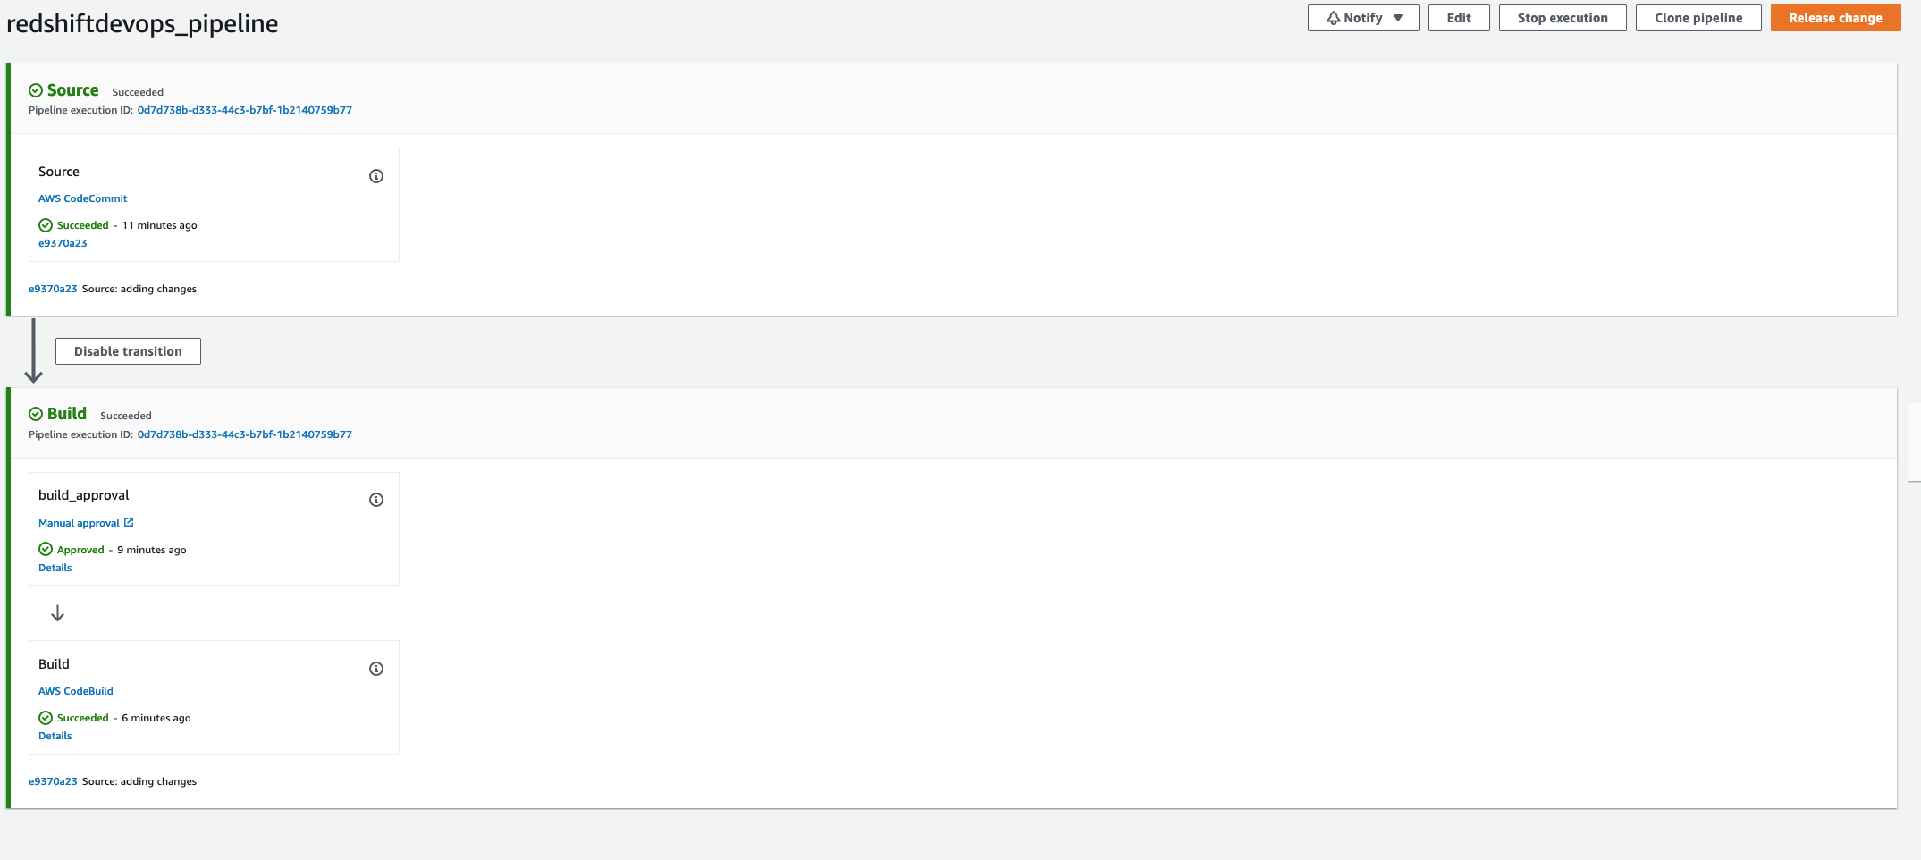

ECS service picks up all the changes and deploys them to Redshift, and the table gets created.

# Conclusion

Using CI/CD principles in the context of Amazon Redshift stored procedures, and schema changes improves the reliability and repeatability of the change management process. Running test cases validates database changes are providing expected output like application code. If the test cases fail, changes can be backed out with a simple rollback command.

In addition, versioning migrations enable consistency across multiple environments and prevent issues arising from schema changes that are not appropriately applied. This increases confidence when changes are made and improves development velocity as teams spend more time developing functionality rather than hunting for issues due to environmental inconsistencies.